***bLogic Specification Template***

|  |  |  |  |
| --- | --- | --- | --- |
| **Student** | Gerardo Galan Garzafox | **Program** | 6 |

|  |  |
| --- | --- |
| **Class Name** | IO |

|  |  |
| --- | --- |
| **Method Name** | read() |

|  |  |
| --- | --- |
| **Parameters** | void |

**Include the image of the activity diagram created for the program:**

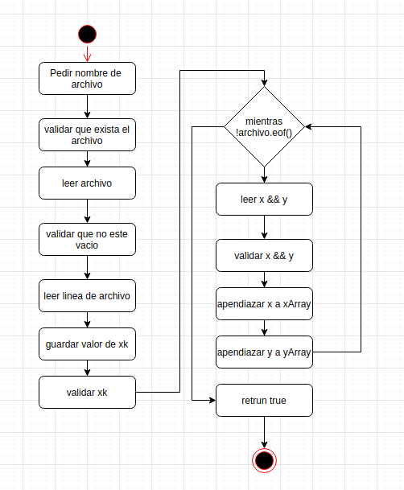

|  |  |
| --- | --- |
| **Class Name** | IO |

|  |  |
| --- | --- |
| **Method Name** | print() |

|  |  |
| --- | --- |
| **Parameters** | data:vector<long double> |

**Include the image of the activity diagram created for the program:**

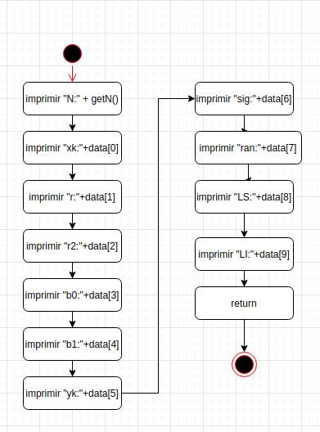

|  |  |
| --- | --- |
| **Class Name** | Regression |

|  |  |
| --- | --- |
| **Method Name** | calcB1():long double |

|  |  |
| --- | --- |
| **Parameters** | null |

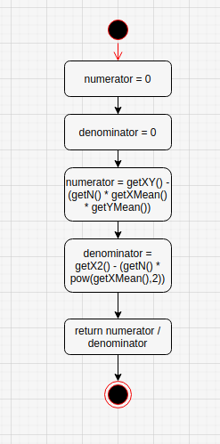

|  |  |
| --- | --- |
| **Class Name** | Regression |

|  |  |
| --- | --- |
| **Method Name** | calcR():long double |

|  |  |
| --- | --- |
| **Parameters** | null |

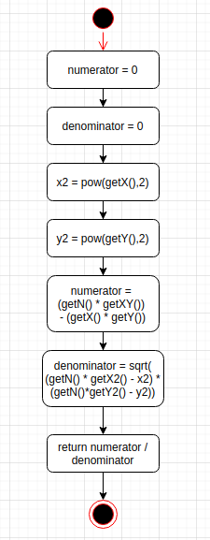

|  |  |
| --- | --- |
| **Class Name** | Regression |

|  |  |
| --- | --- |
| **Method Name** | Regression() |

|  |  |
| --- | --- |
| **Parameters** | null |

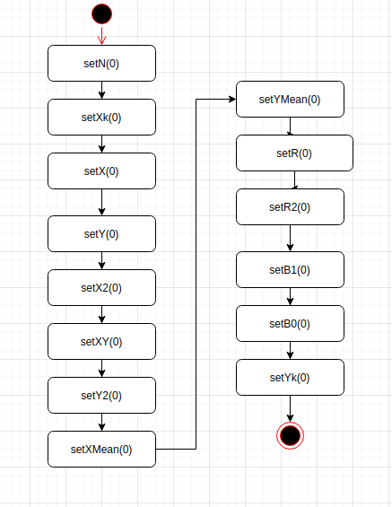

|  |  |
| --- | --- |
| **Class Name** | Regression |

|  |  |
| --- | --- |
| **Method Name** | Regression() |

|  |  |
| --- | --- |
| **Parameters** | x vector<long double> |
|  | y vector<long double> |
|  | int xk |

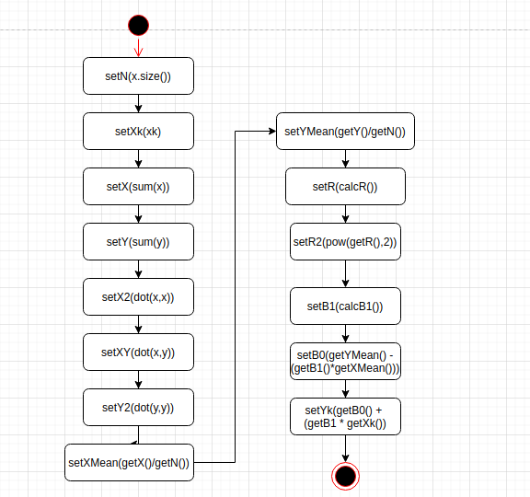

|  |  |
| --- | --- |
| **Class Name** | Calc |

|  |  |
| --- | --- |
| **Method Name** | standardDeviation():long double |

|  |  |
| --- | --- |
| **Parameters** | vector<long double> x |
|  | vector<long double> y |

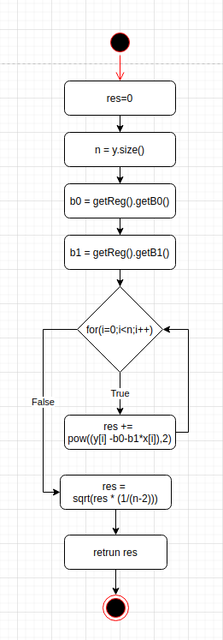

|  |  |
| --- | --- |
| **Class Name** | Calc |

|  |  |
| --- | --- |
| **Method Name** | calcRan():long double |

|  |  |
| --- | --- |
| **Parameters** | vector<long double> x |
|  | vector<long double> y |
|  | int xk |

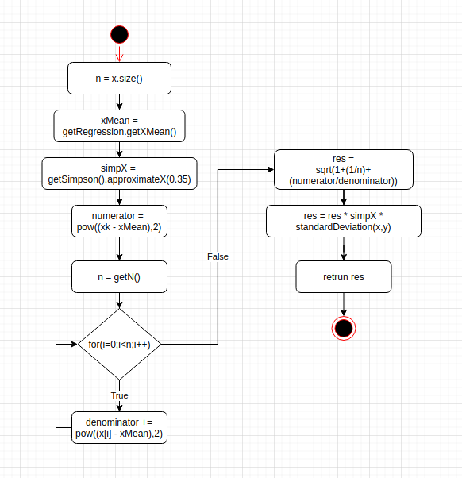

|  |  |
| --- | --- |
| **Class Name** | Calc |

|  |  |
| --- | --- |
| **Method Name** | Calc() |

|  |  |
| --- | --- |
| **Parameters** | vector<long double> x |
|  | vector<long double> y |
|  | int xk |

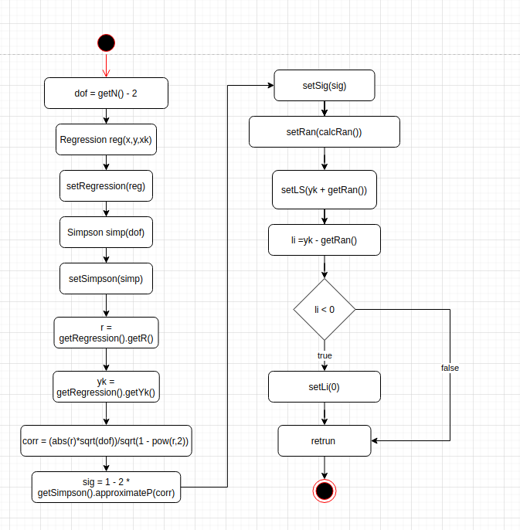

|  |  |
| --- | --- |
| **Class Name** | Calc |

|  |  |
| --- | --- |
| **Method Name** | getData():valarray<long double> |

|  |  |
| --- | --- |
| **Parameters** | void |

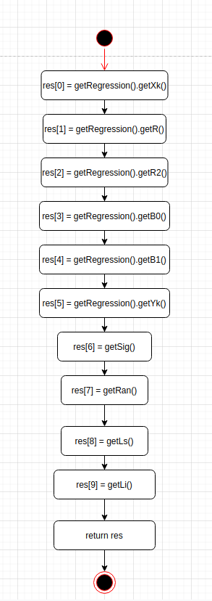

|  |  |
| --- | --- |
| **Class Name** | Main |

|  |  |
| --- | --- |
| **Method Name** | main():int |

|  |  |
| --- | --- |
| **Parameters** | none |

